IDFNZ Board Elections -Candidate Profile
Name:
Class of membership:
(Adult PID patient /
Support member (PID Adult & Youth/ non -PID Youth).
Candidate standing for (please circle)
- Adult (PID) Patient / Support (Patient & PID youth) member
- Support (non PID Youth) member
Please summarise your background, reasons for wanting to stand as a candidate and strengths / skills you can specifically offer IDFNZ. (Please write legibly in black ink).

My name is Vicki Tattley. I am married with three adult children. One diagnosed as mildly immune deficient (transient hypagammagloblin anemia), and the other two affected as well.
I have been involved on the Board of IDFNZ approximately 16 years.

I joined the Board in order to give something back to IDFNZ for the support given to us particularly through the early years of diagnosis, but for which has been a continuing support.
For the past three years I have held the position of Chair. This has enabled me to grow as a person as I proudly have represented the organisation in many areas.

My background was as a parent, and within the field of administration/secretarial employment in the work environment. Five years ago I commenced study toward a Legal Executive Diploma and I am just about to sit the last paper. I have worked within a legal environment for the last 18 months and have recently been employed within a role as Legal Executive which is an exciting culmination of a lot of hard work. I am a people person and enjoy being involved within IDFNZ to bring support to our families.

I would like to continue on the Board as we strive to reach both short and long term goals, and I am a huge supporter of bringing the practical assistance we do to our families as one of our core values.

Candidate's signature•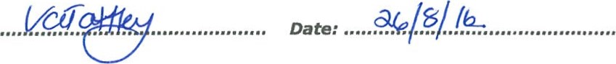
Nb : I understand this form will be circulated to members .
Completed form to be emailed to: info@idfnz.org.nz or mailed to PO Box 75076, Manurewa, Manukau 2243 by.no later than 26th August 2016.

